Most Needed School Supplies Needed
- 1” Binders
- Colored Pencils
- Composition Notebooks (Wide-Ruled Only)
- Tabbed Dividers
- Dry Erase Markers
- Loose Leaf Paper (Wide-Ruled And College-Ruled)
- Plastic 2-Pocket Folders With Prongs
- Glue Sticks
- Index Cards
- Spiral Notebooks (College-Ruled Only)

Financial Contributions are also greatly appreciated! $50 provides a new backpack and supplies for one child. Donations are accepted at UnitedWayofLeeCounty.com or on Venmo @UnitedWayofLeeCountyAL
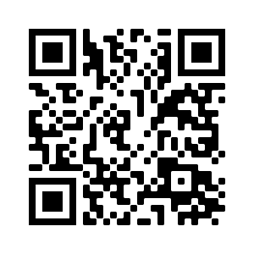

Additional School Supplies Accepted

- 2” Binders
- Pencil Sharpeners
- Composition Notebooks (College-Ruled)
- Loose Leaf Paper (Wide-Ruled And College-Ruled)
- Spiral Notebooks (Wide-Ruled)
- Crayons
- Washable Markers
- Scissors
- Erasers
- Highlighters
- Pens
- Pencil Pouches
- Pencil Boxes
- Zipping Binders

